
SRM Institute of Science and Technology
College of Engineering and Technology
DEPARTMENT OF ECE
SRM Nagar, Kattankulathur – 603203, Chengalpattu District, Tamilnadu
Academic Year: 2021-2022 (EVEN)
Assignment 2
Course Code & Title: 18ECC201J – Analog Electronic Circuits Year & Sem: II / IV
Max. Marks: 60

Course Articulation Matrix :
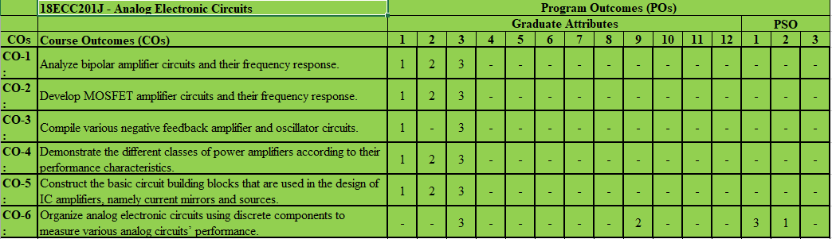
Q. No | Question | Marks | BL | CO | PO
 | A negative feedback amplifier has a closed loop gain of A_{f} = 80 and an open loop gain of A= 10⁵. (a) What is the feedback transfer function β? (b) If the open loop gain decreases by 20 %, determine the percent change in the closed loop gain. What is the new value of A_{f}? (c) Repeat parts (a) and (b) for A=10³. | 10 | 3 | CO3 | 3
 | Consider the ideal series-shunt and shunt-series feedback topology. Let A = 5×10³ V/V, β = 0.0080 V/V, Ri =10 kΩ, and Ro =1 kΩ. Determine the ideal values of Af = Vo/ Vi, Rif and Rof . | 10 | 3 | CO3 | 3
 | - Calculate the operating frequency of a BJT phase-shift oscillator as in Fig. 14.21 b for R = 6 kΩ, C = 1500 pF, and RC = 18 kΩ.  - Calculate the oscillator frequency for an FET Hartley oscillator, for the following circuit values: C = 250 pF, L1 = 1.5 mH, L2 = 1.5 mH, and M = 0.5 mH. | 10 | 3 | CO3 | 3
 | For the circuit in Figure, the bias voltages are V ⁺ = +15 V and V ⁻ = −15 V. Assume Q1 and Q2 are matched, and assume V_{B E (on)} = 0.7 V. Neglecting base currents, find R1 such that I_{REF} = I_{O} = 0.5 mA. (b) The upper terminal of R1 may instead be connected to ground potential. Find R1 such that I_{REF} = I_{O} = 0.5 mA for this case. Discuss any advantage of connecting R1 to ground rather than to the V + power supply. (c) Determine the change in I_{O} if R1 varies by ±5 percent from the design values of parts (a) and (b).  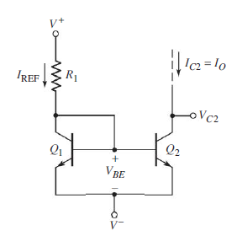 | 10 | 3 | CO5 | 2
 | For the Widlar current source, (a) find I_{REF}, I_{O}, and Ro if R₁ = 100 k, R_{E} = 10 k, V ⁺ = +5 V, and V ⁻ = −5 V. The transistor parameters are V_{BE (on)} = 0.7 V and V_{A} = 30 V. (b) Determine the voltage difference V_{BE1} − V_{BE2}. | 10 | 3 | CO5 | 2
 | Consider the differential amplifier shown in Figure, with transistor parameters of β = 150,  V_{BE (on)} = 0.7 V, and V_{A} = ∞. (a) Design the circuit such that the Q-point values are I_{C1}= I_{C2} = 50μA and V₀₂ = 1.5 V when v₁ = v₂ = 0. (b) Draw the dc load line and plot the Q point for transistor Q2. (c) What are the maximum and minimum values of the common-mode input voltage?  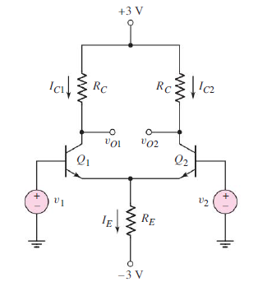 | 10 | 3 | CO5 | 3

Course Outcome (CO) and Bloom’s level (BL) Coverage in Questions 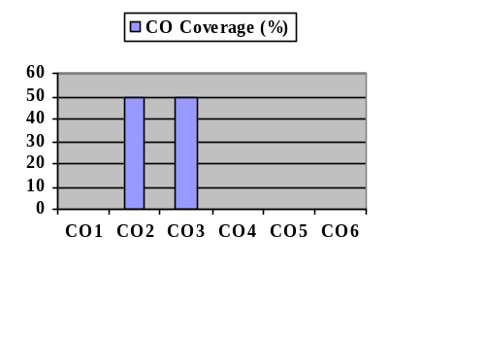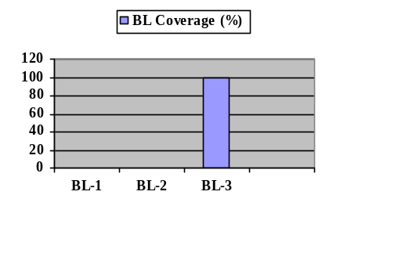

Evaluation Sheet
Name of the Student: Register No.:

Q. No | CO | PO | Maximum Marks | Marks Obtained | Total
1 | CO4 | 3 | 10
2 | CO4 | 3 | 10
3 | CO4 | 3 | 10
4 | CO4 | 2 | 10
5 | CO4 | 2 | 10
6 | CO5 | 3 | 10

Consolidated Marks:

CO | Maximum Marks | Marks Obtained
3 | 30
5 | 30
Total | 60

PO | Maximum Marks | Marks Obtained
2 | 20
3 | 40
Total | 60

